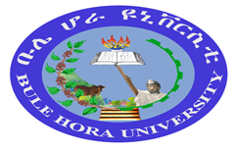
BULE HORA UNIVERSITY
GUJI GIRJA CAMPUS
COLLEGE OF EDUCATION AND BEHAVIORAL SCIENCES (CEBS)
College Administration
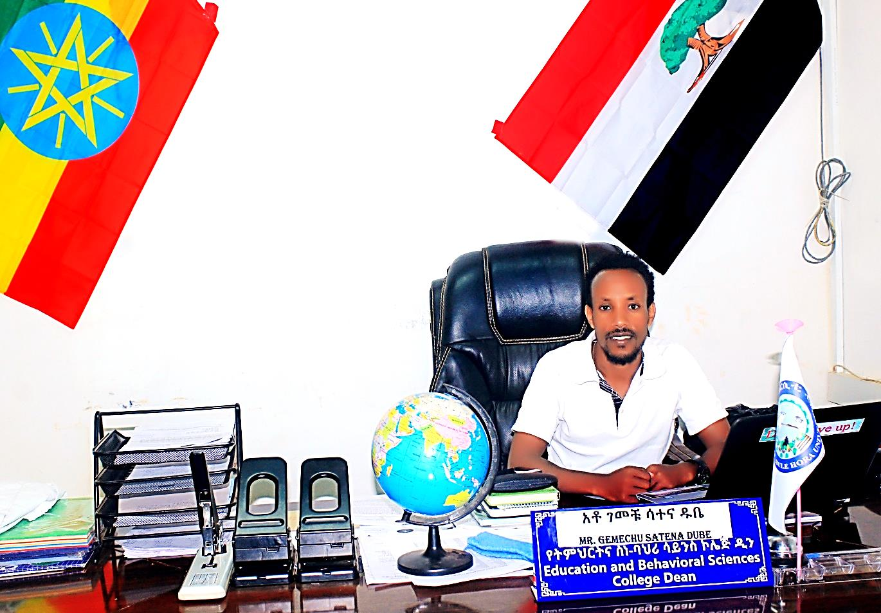
Mr. Gemechu Satena Dube (MA in Social Psychology)
Dean, College of Education and Behavioral Sciences
Mobile: +251910224292/923080794
E-mail: gemechusatena@gmail.com
Office Telephone: +251468227183
P.O.Box: 144
Adola Woyyu, Oromia, Ethipia.

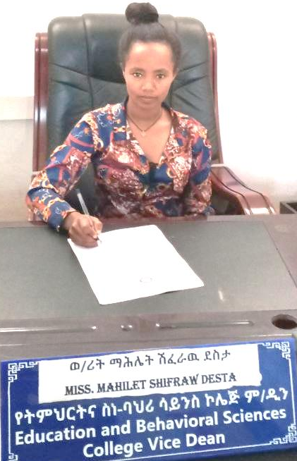
Miss. Mahilet Shifarew Desta (MA in Early Childhood Care and Education)
V/Dean, College of Education and Behavioral Sciences
Mobile: +251923481455
E-mail: mahizebhu@gmail.com
Office Telephone: +251468227183
P.O.Box: 144
Adola Woyyu, Oromia, Ethipia.

OVERVIEWS OF COLLEGE OF EDUCATION AND BEHAVIORAL SCIENCES (CEBS)
College of Education and Behavioral Sciences is one College among Bule Hora University Colleges. The College is located at Adola Woyyu town at Guji Girja Campus. The College was separated from Social Science and Humanity College and established independently in 2011 E.C. After establishment the college moved to Adola Woyyu town in 2012 E.C at Guji Girja Campus.
Core Values of College of Education and Behavioral Sciences
- Excellency
- Quality Education
- Collaboration and teamwork
- Commitment
- Ethics
- Tolerance
- Participatory
- Academic freedom
- Good governance
- Continuous improvement
Vision of College of Education and Behavioral Sciences
- To be the best college of education and behavioral sciences among Ethiopian higher education by 2025 through the provision of quality education, conducting problem solving research, and giving community services.
Mission of College of Education and Behavioral Sciences
- Working for bringing about behavioral changes and to ensuring quality of education.
Programs of the college of Education and Behavioral Sciences
The College is providing programs from BA up to PhD through regular and weekend programs.
In BA: Psychology
Educational Planning and Management (EdPM)
Early Childhood Care and Education (ECCE)
Special Needs and Inclusive Education (SNIE) and
Adult Education and Community Development (AECD)
In MA: Educational Planning and Management (EdPM)
Educational Psychology and
Curriculum and Instruction
In PhD: Educational Leadership and Policy studies.
The Programs were delivering by Regular and Weekend at different centers.
In regular programs, BA in Psychology, BA in Educational Planning and Management, BA in Early Childhood Care and Education, and BA in Special Needs and Inclusive Education, BA in Adult Education and Community Development, MA in Educational Psychology, MA in Educational Planning and Management, and MA in Curriculum and Instruction and PhD in Educational Leadership and Policy studies were delivering at Guji Girja Campus, Adola Woyyu town.
In weekend programs, BA in Adult Education and Community Development and BA in Educational Planning and Management were delivering at Bore Center. MA in Educational Psychology, MA in Educational Planning and Management and MA in Curriculum and Instruction were Delivering at Bule Hora University, Guji Girja Campus and Nagelle town.
The detail information of the departments within its programs is as follows.
- Department of Psychology
Overviews of Department of Psychology
Currently, psychology department is one of the departments under the College of Education and Behavioral Sciences. It was established, as one of the Departments College of Education and Behavioral Sciences, in the year 2011/2018. The department has been running a BA program in Psychology for regular and MA in Educational Psychology program for regular and weekend. In the past four years, 35 students are graduated in the regular program from the department. The graduates are working in different regions and sectors on different fields; and two of them are working as graduate Assistant I (one) in our University.
In both BA and MA levels, the department of psychology aimed to produce well equipped and trained professionals who applies principles, concepts, theories, and practices of psychology and thereby meet the demands of governmental, nongovernmental, and private agencies; to carry out quality research on various psychological, educational and, social problems of the community and; to provide the necessary public services to individuals, institutions, and groups regarding problems and issues pertaining to the field of psychology. In order to do so, the needs of different resources and facilities are beyond doubt. Accordingly, to run the program, psychology department outfitted itself with qualified academicians with various academic statuses (2 associate professors, 1 Ph.D. candidate, 10 MA holders, 8 assistant lecturers, 2 graduate assistant II, and 2 graduate assistant I).
Department Administration
The head of the department is the chief executive of the department.
Name: Ayichluhim Alemishet Tesfaye
Academic Rank: Lecturer
College/Institute: College of Education and Behavioral Sciences
Department/Team: Psychology
Field of Specialization: Clinical Psychology (MSc)
Research Interest: Mental Health, Education, and various Psycho-social issues
List of Publications:
Contact Address
- P. O. Box: 144
- Office Tel:+251-468227183
- Cell Phone: +251923820167/+251912326156
- E-mail Address: ayichluhim2012@gmail.com
Facilities and Services
The department has two classes for undergraduate program and one common smart class for the graduate program with necessary facilities. The department has also common undergraduate and postgraduate computer laboratory. The department has also common library.
Programs
Bachelor of Art:
- BA in Psychology
Master program:
- Master of Arts Degree in Educational Psychology
Staff Profile
No | Instructor Name | Specializations/Academic Rank | Role
1 | Dr. Mandala Chandrachkhar good | Ph.D. in Educational Psychology | -Asso.Prof
2 | Dr. Javed Alam Ishaq | Ph.D. in Educational Psychology | -Asso.Prof
3 | Addis Kebede Adere | PhD candidate in Educational Psychology | -Lecturer
4 | Alemu Dugasa Roro | MA in Educational Psychology | -Lecturer  -Quality Assurance Coordinator of College of Education and Behavioral Sciences
5 | Mohammed Kemal Tola | MA in Educational Psychology | -Lecturer
6 | Desta Wako Gumi | MA in Educational Psychology | -Lecturer
7 | Likasa Fufa Duguma | MA in Educational Psychology | -Lecturer
8 | Mekit Bekele Shewaye | MA in Educational Psychology | -Lecturer
9 | Ayichluhim Alemishet Tesfaye | MSc in Clinical Psychology | -Lecturer  -Head Department of Psychology
10 | Rameta Adem Husen | MSc in Clinical Psychology | -Lecturer  -Registrar Coordinator of College of Education and Behavioral Sciences
11 | Gemechu Satena Dube | MA in Social Psychology | -Lecturer  -Dean of College of Education and Behavioral Sciences
12 | Mekonnen Samuel Shamebo | MA in Counseling Psychology | -Lecturer
13 | Wondimu Kuma Kuso | MA in Counseling Psychology | -Lecturer
14 | Azrar Abrham Mulugeta | BA in Psychology | -Assistant Lecturer
15 | Birbirsa Wako Wata | BA in Psychology | -Assistant Lecturer
16 | Galchu Denbela Tonda | BA in Psychology | -Assistant Lecturer  -Psychology Department Coordinator at main Campus
17 | Temam Said Ogato | BA in Psychology | -Assistant Lecturer
18 | Sherifa Kedir Ansa | MA candidate in Counseling Psychology | -Assistant Lecturer
19 | Dinknesh Tesfaye Gemechu | MA candidate in Social Psychology | -Assistant Lecturer
20 | Bilise Banecha Darso | MA candidate in Social Psychology | -Assistant Lecturer
21 | Dawit Amogne Gondar | MSc candidate in Clinical Psychology | -Assistant Lecturer
22 | Jemal Mude Wabe | BA in Psychology | -Graduate Assistant II
23 | Loko Gelchu Ware | BA in Psychology | -Graduate Assistant II
24 | Netsuh Kibrework Gebresenbet | BA in Psychology | -Graduate Assistant I
25 | Dida Ture Dungaye | BA in Psychology | -Graduate Assistant I

Student Demography
The total numbers of students enrolled currently in the department are 46. Out of these, 28 (61%) are BA students who attend in regular program. The rest 18(39%) are MA students who attend in weekend program. See the student population in the table below.
Program: BA in Psychology (Regular)
Year of study | Male | Female | Total
1st Year | – | – | –
2nd Year | 14 | 1 | 15
3rd Year | 9 | 4 | 13
Total | 23 | 5 | 28
Program: MA in Educational Psychology (Weekend)
Year of study | Male | Female | Total
1st Year | 8 | 1 | 9
2nd Year | 8 | 1 | 9
Total | 16 | 2 | 18

- Department of Educational Planning and Management
Overviews of Department of Educational Planning and Management
The departments were started under the College of Education and Behavioral Sciences that has been established in the 2011/2018 academic year at Bule Hora University in response to the government’s program of expanding and diversifying university education. The objective of establishing the department is to produce an excellent competent educational Leadership expertise who are equipped with the necessary skills and knowledge to solve individuals, and organizational problems of the country and bring about growth to the Ethiopian Education System. Along with the production of professionals, the Department carries public responsibility to back up the development effort of the nation through the provision of quality education, communal problem solving, research activities, community-based service, and many others. Currently, the department of Educational Planning and Management has been radically influencing the advancement in of education leadership that is serving the Community at the vicinity in leadership of Education and many other areas of human endeavor.
For the past four years, the department is offering one undergraduate degree program BA in Educational Planning and Management. Currently, the department has accepted and enrolled more than 98 students under the regular program and 161 students under the weekend undergraduate program.
The Department is running with two post-graduate (MA) programs. namely: MA in Educational Planning and Management both in (Regular and weekend), Curriculum and Instruction both in (Regular and Weekend). Currently around 15 regular and 67 weekend students, Total: 89 students are available on post-graduate MA programs.
The Department also running one post-graduate (PhD) program. namely: PhD in Educational Leadership and Policy Studies in Regular. Currently around 10 regular students are available on post-graduate PhD program.
Staff profile
Regarding to Staff profile there are nine (9) in patriate/local staff and 2 expatriate. There is one (1) PhD (Associate Professor), Two (2) PhD candidates, Three (3) PhD followers and Three (3) MA holders in local staff and both expatriate are PhD (Associate Professor).
No. | Instructors Name | Specialization/ Academic Rank | Role
1 | Dr. Chala Wata Derreso | PhD in International and Comparative Education | -Assoc. Professor
2 | Dr. Pechetty SVR Babu | PhD in Education | -Assoc. Professor
3 | Dr. Naggeshwara Rao | PhD in Education | -Assoc. Professor
4 | Mr. Abraham Ayele Dulo | MA in Curriculum and Quality Assurance | -Lecturer  -PhD Follower
5 | Mr. Asfaw Gelaw Nefa | MA in Educational Leadership | -Lecturer  -PhD Follower
6 | Nega Balcha Tolesa | MA in School Leadership | -PhD Candidate
7 | Selamnesh Getachew Tafesse | MA in Educational Leadership | -PhD Candidate
8 | Taye Mosisa Gemeda | MA in Educational Leadership | -Lecturer  -Head Department  -PhD Follower
9 | Ketema A/Tuke Dube | MA in Educational Leadership | -Lecturer
10 | Ishetu Taddese Chibsa | MA in Educational Leadership | -Lecturer  -College Research and Community Service Coordinator
11 | Shiferaw Terore Beresso | MA in Educational Leadership | -Lecturer  -College Post Graduate Coordinator
Vision of the Department
To be the best Choice, competent and acknowledge among Ethiopian higher education department by 2025 through the provision of quality education, research, and consultancy service in the educational Planning and management field.
Mission of the Department
Providing quality education, conducting problem-solving quality research project, providing access community-based services and produce high competent graduates by EdPM field.
Objectives of the Department
- To provide excellent quality education in Educational Management
- To produce a high-quality graduate with an entrepreneurial and problem-solving mindset
- Educating and training students for the very dynamic and rapidly expansion, changing and sustaining quality education.
- Motivating students to become innovators who can respond very positively to the challenges and opportunities presented by new ideas in education System.
- To provide Educational Leadership related training s and community service
- To conduct problem-solving researches in Educational Management, Planning and Pedagogy focusing on knowledge and Instruction consists of national priority needs.
- Department of Early Childhood Care and Education
Overviews of the Department of Early Childhood Care and Education
Currently, Early Childhood Care and Education department is one department under the College of Education and Behavioral Sciences. It was established as department of College of Education and Behavioral Sciences in the year 2018(2011 E.C). The department has been running a BA program in Early Childhood Care and Education for regular. In the past for four years 29 students are graduated in the regular program from the department. The graduates are working in different regions and sectors on different fields.
In BA level, the department of Early Childhood Care and Education aimed to produce well equipped and trained professionals who applies principles, concepts, theories, and practices of Early Childhood Care and Education and thereby meet the demands of governmental, nongovernmental, and private agencies; to carry out quality research on various child related, educational and, social problems of the community and to provide the necessary public services to individuals, institutions, and groups regarding problems and issues pertaining to the field of Early Childhood Care and Education. In order to do so, the needs of different resources and facilities are beyond doubt. Accordingly, to run the program, Early Childhood Care and Education department outfitted itself with qualified academicians with various academic statuses (3 MA holders, 2 MA candidates, and 1 graduate assistant II.
Department Administration
The head of the department is the chief executive of the department.
Name: Yetbark W/Tsadik
Academic Rank: Graduate assistant II
College/Institute: College of Education and Behavioral Sciences
Department/Team: Early Childhood Care and Education
Field of Specialization: -
Research Interest: - Child related, Early Child Development, Childhood and Education.
List of Publications: -
Contact Address
P. O. Box: 144
- Office Tel:+251-468227183
- Cell Phone: +251916887872
- E-mail Address: gechwendema@gmail.com
Staff profile
No | Instructors Name | Specialization/Academic rank | Role
1 | Yetbark W/Tsadik Nega | BA in Early Childhood Care and Education | - Assistant Lecturer  -Head Department of Early Childhood Care and Education
2 | Mahilet Shifarew Desta | MA in Early Childhood Care and Education | - Lecturer  - Vice Dean of College of Education and Behavioral Sciences
3 | Agumas Andualem Belay | MA in Early Childhood Care and Education | -Lecturer
4 | Mokonnen Nigusie Atinafu | MA in Early Childhood Care and Education | -Lecturer
5 | Mahider Siyum Kidane | MA candidate in Early Childhood Care and Education | - Assistant Lecturer
6 | Chala Garama Iresso | MA candidate in Early Childhood Care and Education | - Assistant Lecturer

Facilities and Services
The department has only one class for undergraduate program but it has common library. Moreover, the department has no common computer.
Programs
Bachelor of Art:
- BA In Early Childhood Care and Education.
Student Demography
The total numbers of students enrolled currently in the department are 33.
See the student information in the table below.
Program: BA in Early Childhood Care and Education. (Regular)
Year of study | Male | Female | Total
1st Year | – | – | –
2nd Year | 11 | 3 | 14
3rd Year | 11 | 8 | 19
Total | 22 | 11 | 33

- Department of Special Needs and Inclusive Education
Overviews of the Department of Special Needs and Inclusive Education
Department of Special Needs and Inclusive Education started students training as a program at Bule Hora University in 2020/2012 to meet the country’s demand for trained human labor in the areas of Special Needs and Inclusive Education as the science of behavior.
The Department gives only the undergraduate program for the sake of start and will plan further for MA programs in the 2016 E.C. The department has currently 14 students in regular undergraduate program.
Mission of Department of Special Needs and Inclusive Education
The mission of the department is to produce students with practical and Special needs skills that would work with the grassroots to contribute towards create awareness inclusive society, poverty reduction, promotion of good cultural practices, shaping human behavior, fighting harmful practices affecting health, productivity, and technological innovations.
Objectives of Department of Special Needs and Inclusive Education
General objectives
The general objective of the program is to:
- Teaching and learning Objective
Produce qualified Special Needs Experts who work in various governmental, nongovernmental, and private agencies
- Research and community service objectives
Carry out quality research on various PWDs, educational and, social issues, and
Offer community services to individuals, institutions, and groups regarding problems and issues pertaining to the field of Special Needs and Inclusive.
Specific objectives
The specific objectives of the training program are to produce professionals who:
- can provide Special Needs and Inclusive Education services in governmental, non-governmental, and private institutions
- would be able to work in various educational settings
- can initiate, organize, and evaluate various educational and social development programs
- render rehabilitation services
- can conduct research on various PWDs, educational and social issues
- can provide demand-based consultation and technical advice to individuals, groups, and institutions .

Staff Profile
No | Instructors Name | Specializations/Academic Rank | Role
1 | Meseret Abate Demlew | MA in Special Needs and Inclusive Education | -Lecturer  - Head Department of Special Needs and Inclusive Education
2 | Jemaledin Suti Seid | MA in Special Needs and Inclusive Education | -Lecturer
3 | Mekuria Chekole Negash | MA Candidate in Special Needs and Inclusive Education | -Assistant Lecturer
4 | Zebegna Mulatu Ameto | MA in Inclusive Education and Rehabilitation | -Lecturer
5 | Tamene Getachew Bambaro | MA in Inclusive Education and Rehabilitation | -Lecturer

Student Demography
The total numbers of students enrolled currently in the department are 14. All are BA students who attend in regular program. See the student population in the table below.
Program: BA in Special Needs and Inclusive Education (Regular)
Year of study | Male | Female | Total
1st Year | – | – | –
2nd Year | - | - | -
3rd Year | 5 | 9 | 14
Total | 5 | 9 | 14

- Department of Adult Education and Community Development
Overviews of the department of Adult Education and Community Development
Department of Adult Education and Community Development were established in 2008 E.C. It is the senior and establisher of the College. However, during the time of its establishment, it was under the faculty of social science and humanities in later, in response to the government’s program of expanding and diversifying University education. The Department was placed under College of Education and Behavioral sciences in the new University structure in 2010 E.C. academic year. During this academic year, the college of Education and Behavioral sciences was separated from the Social sciences and Humanities as a self-regulating college by having four undergraduate departments: namely, Adult Education and Community Development, Educational Planning and management, Psychology and Early childhood care and Education department. Educating community development workers and adult education organizers were among the objectives of the department. Currently, the Department is accepting and enrolling students under regular/weekend programs. The Department staff members are working in research work that is funded by the University starting from its establishment 2010 Academic year. The department staff is also actively participating in community service to solve the social and communal problems and related issues. The Department has graduated 3 batches of students starting from 2011 E.C. the number of students graduated from this department is 116 students in regular mode. A good number of students graduated from our department are working in different positions with higher governmental institutions such as Universities, Education sector in different levels, Non-Government organization (NGO) and other different local and regional offices with different levels of expertise.
Vision
To be the competitive and well known preferable Department in 2020 E.C
Mission
The missions of Department are to:
- Provide quality Personnel within the rapidly evolving areas of Adult Education and Community Development;
- Offer need based community service in Adult Education and Community Development and its application areas.
- Provide capacity development trainings and work with social mobilisers & different development agents
The objective of establishing the department is to
- Train experts who can work in the area of Education and socio economic transformation in Ethiopia
- Strengthen the link between society and creativity so that citizen can work on the their own initiative
- Promote exemplary sustainable social welfare workers/experts.
- Promote and foster conducting solution based research in Adult and non-formal Education, Community Development and socio-economic transformation in line with the national needs.
- Promoting indigenous knowledge of society and equipping learners with the required knowledge and skills demanded by the latest technology.
- A rigorous theoretical knowledge and understanding as well as detailed practical experience of community mobilization and lifelong learning
- Bear experts who are responsible and accountable towards his/her nation via closing the gaps /needs of community.
With regard to staff account, Department of Adult Education and Community Development has currently six lecturers and one assistant lecturer. In addition to this, the table below expresses the staff’s profile
Here the staffs are listed below:
No | Name of Instructors | Area of Specialization/ Academic rank | Role
1 | Tadesse Manna | MA in Adult Education and Community Development(AECD) | -Lecturer  - Head Department of Adult Education and Community Development
2 | Asnake Chernet | MA in Adult Education and community Development(AECD) | -Lecturer
3 | Daki wako | MA Candidate in Adult Education and Community Development(AECD) | -Assistant Lecturer
4 | Kasahun Alemu | MA in Adult Education and Community Development(AECD) | -Lecturer
5 | Niguse Degife | MA in Adult Education and Community Development(AECD) | -Lecturer
6 | Atnafu Haro | MA in Adult Education and Community Development(AECD) | -Lecturer
7 | Habte Tefera | MA in Curriculum and Instruction | -Lecturer

Professional profile
Adult Education and Community Development program should enable graduates to acquire both theoretical and practical knowledge to the profession. So that they will be competent locally, nationally and internationally. It should transfer employability skill in an ethical manner that can be reflected through the cognitive ability, interpersonal skill, organizational skill and research skill of the graduates
The graduates of Adult Education and Community Development with BA degree in Adult Education and Community Development, therefore can work as
- Community development worker/social worker
- Adult and non-formal Education curriculum experts
- Adult and Non-formal education experts, coordinator and managers
- Continuous professional development coordinators
- Work place learning planners and facilitators
- Community mobiliser agent
- Pastoral education organizers, coordinators, managers and supervisors
- Technical vocational education and training (TVET) coordinators and supervisors
- Continuous education organizer coordinators managers and supervisors
- Gender and social welfare advocators
- Micro and small scale enterprise coordinators
- Project and program designers, coordinators, managers and evaluators
- Trainers and capacity building experts
- Community health protection facilitators
- Lifelong learning experts
- Research experts
Therefore, the graduates of Adult Education and Community Development will have the opportunities to secure employment in wide range of education and community development organization and institution both locally and internationally. For example Graduates from Adult Education and Community Development work in the following sector and organization
- Regional, Zonal, Woreda and Sub city level Education bureaus
- Regional, Zonal, Woreda and Sub city level women and children affairs
- Regional, Zonal, Woreda and Sub city level agricultural and rural development bureaus
- Regional, Zonal, Woreda and Sub city level youth and sport affairs
- Pastoral Community Education and Development Sectors
- Regional, Zonal, Woreda and Sub city level Labor and Social affairs
- Prison /Correctional Education Sectors
- Regional, Zonal, Woreda and Sub city level micro, small and medium enterprises
- Regional, Zonal, Woreda and Sub city level TVET agencies
- Community based organization/community resource mobilization and development organization
- National and International Non-Governmental Organization (NGOs) and civil society organization(CSOs)
- Institute of higher learning(College and University), School
- Regional, Zonal, Woreda and Sub city level administrative office
- Community skill training center
- Leadership training/management institute
Contact Location of the department: College of Education and Behavioral Sciences, Guji Girja Campus
Head, Department of Adult Education and Community Development
Name: Tadesse Manna (MA)
Email: tademena64@gmail.com
Mobile phone: +251935478684
Office Tel: +251-468227183

